User Manual

Programming DA16200 with SEGGER J-Link in Eclipse

UM-<X>-<nnn>

Abstract

The abstract must describe the target hardware or software and the purpose of this document. Optionally the measurement method, results and conclusions can be added when applicable.

Do not remove this section break!

Contents

Abstract 1

Contents 2

Figures 2

Tables 2

1 Terms and Definitions 3

2 References 3

3 Introduction 4

4 Requirements 4

5 Preparation 4

6 Setup 5

6.1 The Flash Loader installation 5

6.2 The path of J-Link installation in Eclipse 7

6.3 Import the 'scripts' project in Eclipse 8

7 Programming 9

Appendix A <Appendix Title> 12

A.1 <Appendix Subsection> 12

Revision History 13

Figures

Figure 1: The installation of the J-Link software package 5

Figure 2: JLinkDevices.xml 5

Figure 3: The flash loader files 6

Figure 4: The path of J-Link installation in Eclipse 7

Figure 5: Import the scripts project 8

Figure 6: Project Explorer 9

Figure 7: Run jlink_program_all script 9

Figure 8: Quick run jlink_program_all script 10

Figure 9. Popup window for selecting the target SFLASH. 11

Figure 10. List of supported SFLASHs 11

Tables

Table 1: <Table Title> 2

# Terms and Definitions

Optional section. Define acronyms and abbreviations used in this document. Use sentence case for acronym definitions.

<TERM> <Definition>

<TERM> <Definition>

Etc.

# References

List the documents that are relevant for readers of this document. Avoid hyperlinked references.

1. <PART_NUMBER>, Datasheet, Revision, Dialog Semiconductor.
2. <AN-X-XXX>, <Title>, Application Note, Revision, Dialog Semiconductor.
3. <UM-X-XXX>, <Title>, User Manual, Revision, Dialog Semiconductor.
4. <Author>, <Title>, <Publication>, <Publisher>, Revision <Rev>, <YYYY>.
5. Etc.

# Introduction

The following chapter introduces the way of programming DA16200 firmware with SEGGER J-link.

# Requirements

1. J-Link Lite or higher (https://www.segger.com/products/debug-probes/j-link/models/model-overview/)

2. J-Link software V6.98 or later (<https://www.segger.com/downloads/jlink/>)

3. Eclipse 2021-06 (4.20.0) ([Eclipse Downloads | The Eclipse Foundation](https://www.eclipse.org/downloads/))

4. Python 2.7 or higher (<https://www.python.org/downloads/>)

# Preparation

The J-Link setup procedure required in order to work with J-Flash is described in chapter 2 of the J-Link / J-Trace User Guide (UM08001).

# Setup

## The Flash Loader installation

In order to use the flash loader for DA16200, it should be installed with the following steps.

1. Browse to the installation of the J-Link software package(ex. C:\Program Files (x86)\SEGGER\JLink). You should now see JFlash.exe, JLinkDevices.xml, ...

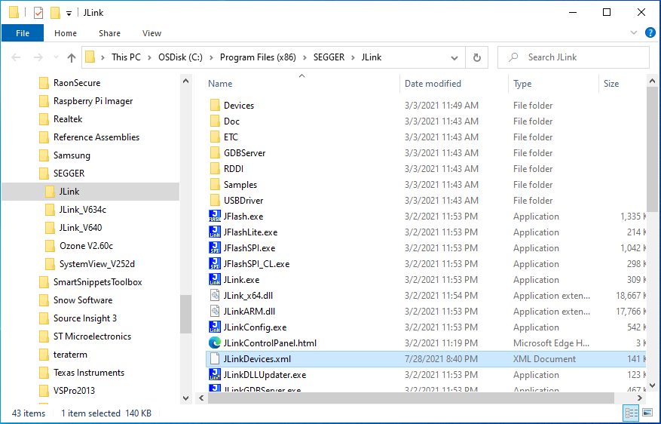

Figure 1: The installation of the J-Link software package

1. Open JLinkDevices.xml in a text editor and add the device entry at the beginning, right after the <Database> opening tag.

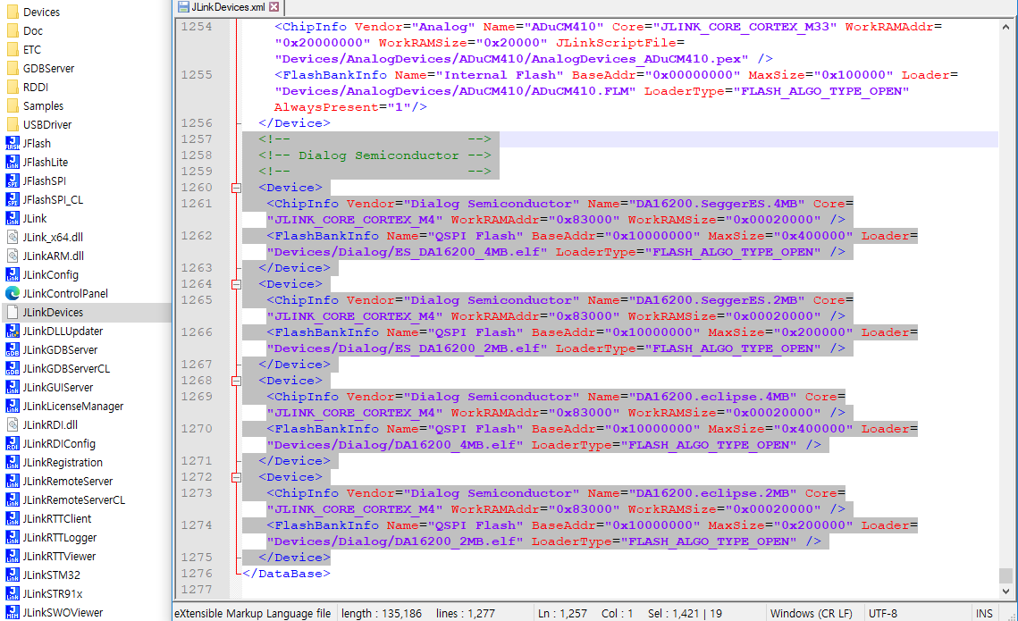

Figure 2: JLinkDevices.xml

|  |
| --- |
| <!-- -->  <!-- Dialog Semiconductor -->  <!-- -->  <Device>  <ChipInfo Vendor="Dialog Semiconductor" Name="DA16200.SeggerES.4MB" Core="JLINK_CORE_CORTEX_M4" WorkRAMAddr="0x83000" WorkRAMSize="0x00020000" />  <FlashBankInfo Name="QSPI Flash" BaseAddr="0x10000000" MaxSize="0x400000" Loader="Devices/Dialog/ES_DA16200_4MB.elf" LoaderType="FLASH_ALGO_TYPE_OPEN" />  </Device>  <Device>  <ChipInfo Vendor="Dialog Semiconductor" Name="DA16200.SeggerES.2MB" Core="JLINK_CORE_CORTEX_M4" WorkRAMAddr="0x83000" WorkRAMSize="0x00020000" />  <FlashBankInfo Name="QSPI Flash" BaseAddr="0x10000000" MaxSize="0x200000" Loader="Devices/Dialog/ES_DA16200_2MB.elf" LoaderType="FLASH_ALGO_TYPE_OPEN" />  </Device>  <Device>  <ChipInfo Vendor="Dialog Semiconductor" Name="DA16200.eclipse.4MB" Core="JLINK_CORE_CORTEX_M4" WorkRAMAddr="0x83000" WorkRAMSize="0x00020000" />  <FlashBankInfo Name="QSPI Flash" BaseAddr="0x10000000" MaxSize="0x400000" Loader="Devices/Dialog/DA16200_4MB.elf" LoaderType="FLASH_ALGO_TYPE_OPEN" />  </Device>  <Device>  <ChipInfo Vendor="Dialog Semiconductor" Name="DA16200.eclipse.2MB" Core="JLINK_CORE_CORTEX_M4" WorkRAMAddr="0x83000" WorkRAMSize="0x00020000" />  <FlashBankInfo Name="QSPI Flash" BaseAddr="0x10000000" MaxSize="0x200000" Loader="Devices/Dialog/DA16200_2MB.elf" LoaderType="FLASH_ALGO_TYPE_OPEN" />  </Device> |

1. Copy the flash loader files (sdk_root\utility\j-link\scripts\flashloader\Devices\Dialog), referenced in the JLinkDevices.xml entry, into the same directory where also the JLinkDevices.xml is located.

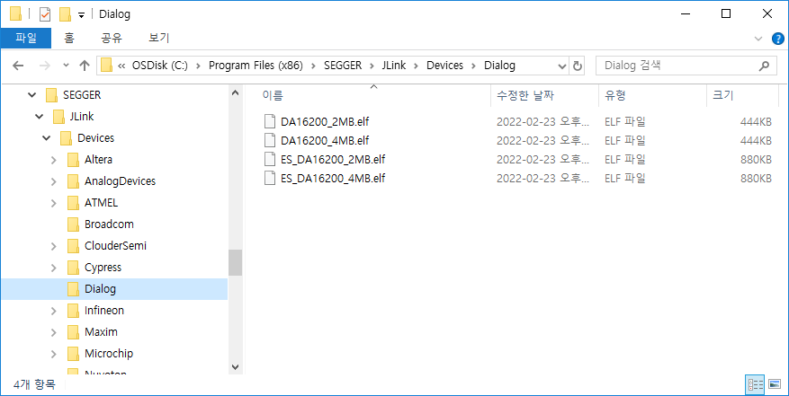

Figure 3: The flash loader files

## The path of J-Link installation in Eclipse

1. Go to Menu > Window > Preferences > Run/Debug > String Substitution
2. Select 'New...'
3. Input the name as 'jlink_path' and the variable as the path of installation of the J-Link software (ex. C:\Program Files (x86)\SEGGER\JLink).

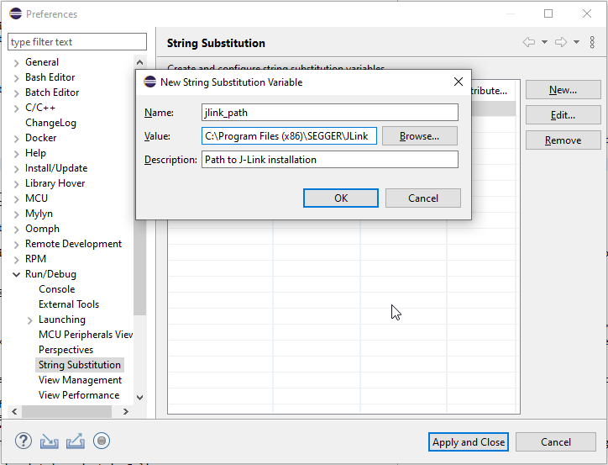

Figure 4: The path of J-Link installation in Eclipse

## Import the 'scripts' project in Eclipse

In order to use the scripts, the scripts project sould be imported in the workspace. The location of the project is sdk_root/utility/j-link/project/SDKJFlash.

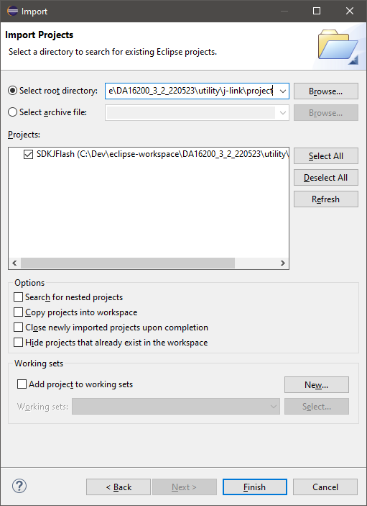

Figure 5: Import the scripts project

# Programming

In order to program binaries into the target device, run 'jlink_program_all_win' script in the External Tools.

1. Select a project in the Project Explorer to be programmed.

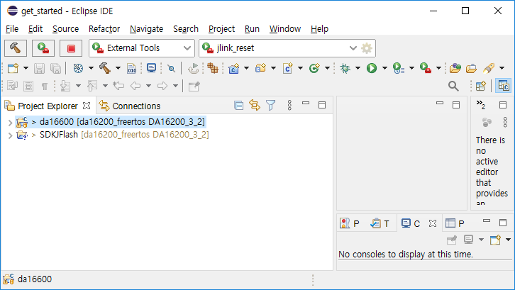

Figure 6: Project Explorer

1. Go to Menu > Run > External Tools.
2. Select 'jlink_program_all_win'.

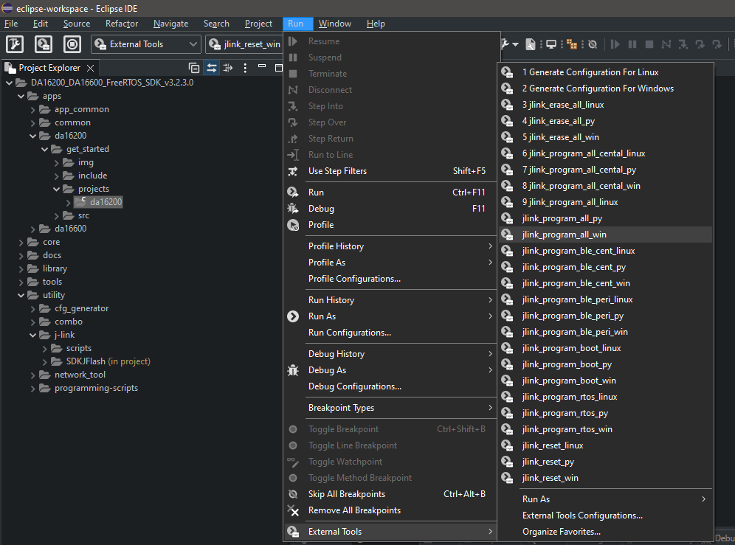

Figure 7: Run jlink_program_all script

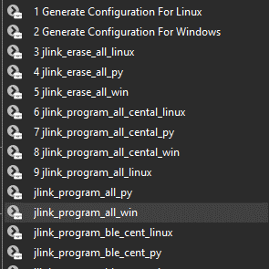

Figure 8: Quick run jlink_program_all script

The included scripts in the SDK are the following :

- jlink_erase_all : Erase all contents of the flash memory.

- jlink_program_all : Program all images into the flash memory.

- jlink_program_boot : Program BOOT image into the flash memory.

- jlink_program_rtos : Program RTOS image into the flash memory.

- jlink_program_all_central : Program all images for BLE central role into the flash memory. (For DA16600)

- jlink_program_ble_peri : Program BLE image for a peripheral role into the flash memory. (For DA16600)

- jlink_program_ble_cent : Program BLE image for a central role into the flash memory. (For DA16600)

- jlink_reset : Reset the target system

1. If no bootable image exists (or if there are multiple bootable images), a popup window may appear to select the target SFLASH.

- jlink_erase_all, jlink_reset_all, jlink_program_rtos, …

- erase/reset scripts will select and run the correct SFLASH again from the flash loader  
 regardless of the manually selected SFLASH.

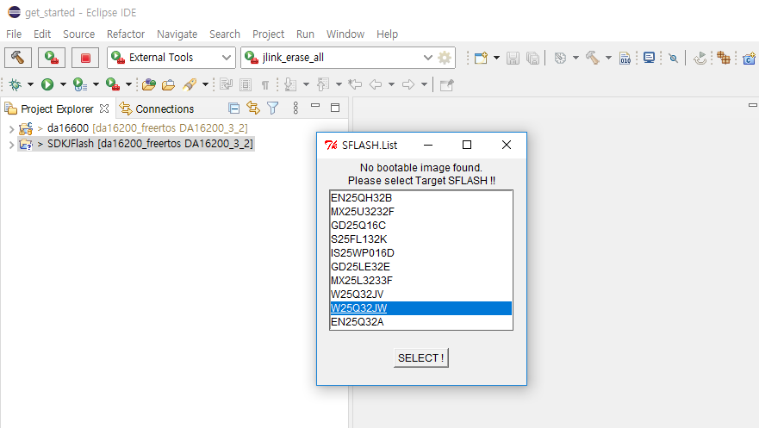

Figure 9. Popup window for selecting the target SFLASH.

5. SFLASHTable.cfg in 'JLINK' folder shoud not be modified. This file shows the list of SFLASHs supported by the flash loader, DA16200_xMB.elf or ES_DA16200_xMB.elf.

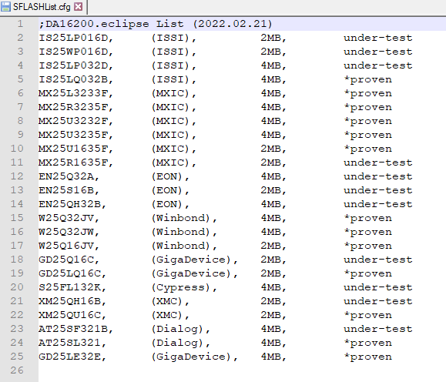

Figure 10. List of supported SFLASHs

1. <Appendix Title>

Optional section, remove if not required. Add subsections as required (Appendix Heading 2 to 5).

<Insert text here>

* 1. <Appendix Subsection>

<Insert text here>

Revision History

Summarize the changes made to the product and/or the document, which are relevant to the customer. The latest revision is shown at the top of the Revision History table. Optionally show change details for the latest revision in a separate table row, with hyperlinks to the related sections.

|  |  |  |
| --- | --- | --- |
| Revision | Date | Description |
| <M> | <DD-Mmm-YYYY> | <Latest revision. Summary of important changes.> |
| Change details: | | |
| 1 | <DD-Mmm-YYYY> | Initial version. |

**Approvals**

This section should be completed by the author. As a style of hidden text, it does not appear in the final document. Please refer to section 6.1 of [CQD1008](http://dms/sites/Forms/QualityTemplates/CQD1008.docx) for further guidance.

|  |  |  |  |
| --- | --- | --- | --- |
| **Function** | **Section(s) Reviewed** | **Name** | **Date of Approval** |
| <Function> | <Section number(s)> | <Name> | <DD-Mmm-YYYY> |
| <Function> | <Section number(s)> | <Name> | <DD-Mmm-YYYY> |
| <Function> | <Section number(s)> | <Name> | <DD-Mmm-YYYY> |
| <Function> | <Section number(s)> | <Name> | <DD-Mmm-YYYY> |

Status Definitions

|  |  |
| --- | --- |
| Status | Definition |
| DRAFT | The content of this document is under review and subject to formal approval, which may result in modifications or additions. |
| APPROVED or unmarked | The content of this document has been approved for publication. |

Disclaimer

Unless otherwise agreed in writing, the Dialog Semiconductor products (and any associated software) referred to in this document are not designed, authorized or warranted to be suitable for use in life support, life-critical or safety-critical systems or equipment, nor in applications where failure or malfunction of a Dialog Semiconductor product (or associated software) can reasonably be expected to result in personal injury, death or severe property or environmental damage. Dialog Semiconductor and its suppliers accept no liability for inclusion and/or use of Dialog Semiconductor products (and any associated software) in such equipment or applications and therefore such inclusion and/or use is at the customer’s own risk.

Information in this document is believed to be accurate and reliable. However, Dialog Semiconductor does not give any representations or warranties, express or implied, as to the accuracy or completeness of such information. Dialog Semiconductor furthermore takes no responsibility whatsoever for the content in this document if provided by any information source outside of Dialog Semiconductor.

Dialog Semiconductor reserves the right to change without notice the information published in this document, including, without limitation, the specification and the design of the related semiconductor products, software and applications. Notwithstanding the foregoing, for any automotive grade version of the device, Dialog Semiconductor reserves the right to change the information published in this document, including, without limitation, the specification and the design of the related semiconductor products, software and applications, in accordance with its standard automotive change notification process.

Applications, software, and semiconductor products described in this document are for illustrative purposes only. Dialog Semiconductor makes no representation or warranty that such applications, software and semiconductor products will be suitable for the specified use without further testing or modification. Unless otherwise agreed in writing, such testing or modification is the sole responsibility of the customer and Dialog Semiconductor excludes all liability in this respect.

Nothing in this document may be construed as a license for customer to use the Dialog Semiconductor products, software and applications referred to in this document. Such license must be separately sought by customer with Dialog Semiconductor.

All use of Dialog Semiconductor products, software and applications referred to in this document is subject to Dialog Semiconductor’s [Standard Terms and Conditions of Sale](https://www.dialog-semiconductor.com/standard-terms-and-conditions-sale), available on the company website ([www.dialog-semiconductor.com](http://www.dialog-semiconductor.com/)) unless otherwise stated.

Dialog, Dialog Semiconductor and the Dialog logo are trademarks of Dialog Semiconductor Plc or its subsidiaries. All other product or service names and marks are the property of their respective owners.

© 2022 Dialog Semiconductor. All rights reserved.

RoHS Compliance

Dialog Semiconductor’s suppliers certify that its products are in compliance with the requirements of Directive 2011/65/EU of the European Parliament on the restriction of the use of certain hazardous substances in electrical and electronic equipment. RoHS certificates from our suppliers are available on request.

|  |  |
| --- | --- |
| Contact Dialog Semiconductor | |
| General Enquiry: | Local Offices: |
| [Enquiry Form](https://www.dialog-semiconductor.com/company/inquiry) | <https://www.dialog-semiconductor.com/contact/sales-offices> |